Datapath – Vhdl – Part B

Niall Martin Ryan - 14315886

Datapath.vhd

library IEEE;

use IEEE.STD_LOGIC_1164.ALL;

use IEEE.NUMERIC_STD.ALL;

entity DataPath is

port(

des_sel : in std_logic_vector(2 downto 0);

load_enable : in std_logic;

dataS : in std_logic;

A_sel : in std_logic_vector(2 downto 0);

B_sel : in std_logic_vector(2 downto 0);

instruction_MB : in std_logic_vector(15 downto 0);

INL : in std_logic;

INR : in std_logic;

Data_in : in std_logic_vector(15 downto 0);

Clk : in std_logic;

fselect : in std_logic_vector(4 downto 0);

MB_sel : in std_logic;

MD_sel : in std_logic;

v : out std_logic;

c : out std_logic;

n : out std_logic;

z : out std_logic;

Adrs_out : out std_logic_vector(15 downto 0);

Data_out_bus_b : out std_logic_vector(15 downto 0);

Control_word : in std_logic_vector(16 downto 0)

);

end DataPath;

architecture Behavioral of DataPath is

-- signals

signal reg0_q, reg1_q, reg2_q, reg3_q, reg4_q, reg5_q, reg6_q, reg7_q : std_logic_vector(15 downto 0);

signal A_output, B_output, Mb_output, Md_output, functional_unit_output : std_logic_vector(15 downto 0);

signal A_address_out, B_data_out: std_logic_vector(15 downto 0);

-- control word signal

signal control_word_transfer : std_logic_vector (16 downto 0);

component Reg_File port(

d0 : in STD_LOGIC;

d1 : in STD_LOGIC;

d2 : in STD_LOGIC;

m0 : in STD_LOGIC;

m1 : in STD_LOGIC;

m2 : in STD_LOGIC;

m3 : in STD_LOGIC;

m4 : in STD_LOGIC;

m5 : in STD_LOGIC;

data : in STD_LOGIC_VECTOR(15 DOWNTO 0);

dataS : in STD_LOGIC;

Clk : in STD_LOGIC;

Data_into_reg : in STD_LOGIC_VECTOR(15 downto 0);

src_output_a : out std_logic_vector(15 downto 0);

src_output_b : out std_logic_vector(15 downto 0);

R0 : out STD_LOGIC_VECTOR(15 DOWNTO 0);

R1 : out STD_LOGIC_VECTOR(15 DOWNTO 0);

R2 : out STD_LOGIC_VECTOR(15 DOWNTO 0);

R3 : out STD_LOGIC_VECTOR(15 DOWNTO 0);

R4 : out STD_LOGIC_VECTOR(15 DOWNTO 0);

R5 : out STD_LOGIC_VECTOR(15 DOWNTO 0);

R6 : out STD_LOGIC_VECTOR(15 DOWNTO 0);

R7 : out STD_LOGIC_VECTOR(15 DOWNTO 0));

end component;

component Mux_2_1 port(

sel : in std_logic;

a : in std_logic_vector(15 downto 0);

b : in std_logic_vector(15 downto 0);

g : out std_logic_vector(15 downto 0)

);

end component;

component Functional_Unit port(

fsel : in std_logic_vector(4 downto 0);

a : in std_logic_vector(15 downto 0);

b : in std_logic_vector(15 downto 0);

IL : in std_logic;

IR : in std_logic;

f : out std_logic_vector(15 downto 0);

v : out std_logic;

c : out std_logic;

n : out std_logic;

z : out std_logic

);

end component;

begin

control_word_transfer <= Control_word;

control_word_transfer(16) <= des_sel(2);

control_word_transfer(15) <= des_sel(1);

control_word_transfer(14) <= des_sel(0);

control_word_transfer(13) <= A_sel(2);

control_word_transfer(12) <= A_sel(1);

control_word_transfer(11) <= A_sel(0);

control_word_transfer(10) <= B_sel(2);

control_word_transfer(9) <= B_sel(1);

control_word_transfer(8) <= B_sel(0);

control_word_transfer(7) <= MB_sel;

control_word_transfer(6) <= fselect(4);

control_word_transfer(5) <= fselect(3);

control_word_transfer(4) <= fselect(2);

control_word_transfer(3) <= fselect(1);

control_word_transfer(2) <= fselect(0);

control_word_transfer(1) <= MD_sel;

control_word_transfer(0) <= dataS;

functional : Functional_Unit port map(

fsel => fselect,

a => A_output,

b => Mb_output,

f => functional_unit_output,

IR => INL,

IL => INR,

v => v,

c => c,

n => n,

z => z

);

reg : Reg_File port map(

d0 => des_sel(0),

d1 => des_sel(1),

d2 => des_sel(2),

m0 => A_sel(0),

m1 => A_sel(1),

m2 => A_sel(2),

m3 => B_sel(0),

m4 => B_sel(1),

m5 => B_sel(2),

Clk => Clk,

Data_into_reg => Md_output,

src_output_a => A_output ,

src_output_b => B_output ,

R0 => reg0_q,

R1 => reg1_q,

R2 => reg2_q,

R3 => reg3_q,

R4 => reg4_q,

R5 => reg5_q,

R6 => reg6_q,

R7 => reg7_q

);

MB_select : Mux_2_1 port map(

a => B_output,

b => instruction_MB,

sel => Mb_sel,

g => Mb_output

);

MD_select : Mux_2_1 port map(

a => functional_unit_output,

b => data_in,

sel => MD_sel,

g => Md_output

);

Adrs_out <= A_output;

Data_out_bus_b <= B_output;

end Behavioral;

Functional_Unit.vhd

library IEEE;

use IEEE.STD_LOGIC_1164.ALL;

entity Functional_Unit is

port(

fsel : in std_logic_vector(4 downto 0);

a : in std_logic_vector(15 downto 0);

b : in std_logic_vector(15 downto 0);

f : out std_logic_vector(15 downto 0);

IL : in std_logic;

IR : in std_logic;

v : out std_logic;

c : out std_logic;

n : out std_logic;

z : out std_logic

);

end Functional_Unit;

architecture Behavioral of Functional_Unit is

-- signals

--input

signal A_input, B_input, B_shifter, ALU_output, Shifter_output, zero_detect_output : std_logic_vector(15 downto 0);

signal Shift_left_input, Shift_right_input, Shift_left_output, Shift_right_output, z_flag : std_logic;

--output

signal OUTPUT : std_logic_vector(15 downto 0);

-- add components

component ALU port(

A, B : in std_logic_vector(15 downto 0);

S1 : in std_logic;

S2 : in std_logic;

S3 : in std_logic;

Cin : in std_logic;

G : out std_logic_vector(15 downto 0);

c : out std_logic

);

end component;

component Shifter port(

IL : in std_logic;

IR : in std_logic;

s : in std_logic_vector(1 downto 0);

b : in std_logic_vector (15 downto 0);

O : out std_logic_vector(15 downto 0);

SL0 : out std_logic;

SR0 : out std_logic

);

end component;

component zeroDetect port(

input : in std_logic_vector(15 downto 0);

outputFlag : out std_logic;

output : out std_logic_vector(15 downto 0)

);

end component;

component Mux_2_1 port(

sel : in std_logic;

a : in std_logic_vector(15 downto 0);

b : in std_logic_vector(15 downto 0);

g : out std_logic_vector(15 downto 0)

);

end component;

begin

Shift_left_input <= IR;

Shift_right_input <= IL;

ariLogUnit : ALU

port map(

A => A,

B => A,

S3 => fsel(3),

S2 => fsel(2),

S1 => fsel(1),

Cin => fsel(0),

G => ALU_output,

c => c

);

shift : Shifter

port map(

IL => Shift_left_input,

IR => Shift_right_input,

S(1) => fsel(3),

S(0) => fsel(2),

b => b,

O => Shifter_output,

SL0 => Shift_left_output,

SR0 => Shift_right_output

);

detect_Zero : zeroDetect

port map(

input => ALU_output,

outputFlag => z,

output => zero_detect_output

);

MF_Select : Mux_2_1

port map(

sel => fsel(4),

a => zero_detect_output,

b => Shifter_output,

g => f

);

end Behavioral;

Reg_File.vhd

library IEEE;

use IEEE.STD_LOGIC_1164.ALL;

entity Reg_File is

Port (

d0 : in STD_LOGIC;

d1 : in STD_LOGIC;

d2 : in STD_LOGIC;

m0 : in STD_LOGIC;

m1 : in STD_LOGIC;

m2 : in STD_LOGIC;

m3 : in STD_LOGIC;

m4 : in STD_LOGIC;

m5 : in STD_LOGIC;

data : in STD_LOGIC_VECTOR(15 DOWNTO 0);

dataS : in STD_LOGIC;

Clk : in STD_LOGIC;

Data_into_reg : in STD_LOGIC_VECTOR(15 downto 0);

src_output_a : out std_logic_vector(15 downto 0);

src_output_b : out std_logic_vector(15 downto 0);

R0 : out STD_LOGIC_VECTOR(15 DOWNTO 0);

R1 : out STD_LOGIC_VECTOR(15 DOWNTO 0);

R2 : out STD_LOGIC_VECTOR(15 DOWNTO 0);

R3 : out STD_LOGIC_VECTOR(15 DOWNTO 0);

R4 : out STD_LOGIC_VECTOR(15 DOWNTO 0);

R5 : out STD_LOGIC_VECTOR(15 DOWNTO 0);

R6 : out STD_LOGIC_VECTOR(15 DOWNTO 0);

R7 : out STD_LOGIC_VECTOR(15 DOWNTO 0));

end Reg_File;

architecture Behavioral of Reg_File is

-- Components

-- reg16

COMPONENT reg16

PORT(

D: IN STD_LOGIC_VECTOR(15 DOWNTO 0);

load: IN STD_LOGIC;

Clk: IN STD_LOGIC;

Q: OUT STD_LOGIC_VECTOR(15 DOWNTO 0)

);

END COMPONENT;

--3 to 8 decoder

COMPONENT Decoder38_16bit

PORT(

S0: IN STD_LOGIC;

S1: IN STD_LOGIC;

S2: IN STD_LOGIC;

dR0: OUT STD_LOGIC;

dR1: OUT STD_LOGIC;

dR2: OUT STD_LOGIC;

dR3: OUT STD_LOGIC;

dR4: OUT STD_LOGIC;

dR5: OUT STD_LOGIC;

dR6: OUT STD_LOGIC;

dR7: OUT STD_LOGIC

);

END COMPONENT;

--8in 16 bit mux

COMPONENT Mux8in_16bit

PORT(

S0: IN STD_LOGIC;

S1: IN STD_LOGIC;

S2: IN STD_LOGIC;

R0: IN STD_LOGIC_VECTOR(15 downto 0);

R1: IN STD_LOGIC_VECTOR(15 downto 0);

R2: IN STD_LOGIC_VECTOR(15 downto 0);

R3: IN STD_LOGIC_VECTOR(15 downto 0);

R4: IN STD_LOGIC_VECTOR(15 downto 0);

R5: IN STD_LOGIC_VECTOR(15 downto 0);

R6: IN STD_LOGIC_VECTOR(15 downto 0);

R7: IN STD_LOGIC_VECTOR(15 downto 0);

OUTPUT: OUT STD_LOGIC_VECTOR(15 downto 0)

);

END COMPONENT;

--2 to 1 line multiplexer 16 bit

COMPONENT Small_Mux

PORT(

In0: IN STD_LOGIC_VECTOR(15 downto 0);

In1: IN STD_LOGIC_VECTOR(15 downto 0);

S: IN STD_LOGIC;

output: OUT STD_LOGIC_VECTOR(15 downto 0)

);

END COMPONENT;

--signals

signal load_reg0, load_reg1, load_reg2, load_reg3, load_reg4, load_reg5,

load_reg6, load_reg7: STD_LOGIC;

signal reg0_q, reg1_q, reg2_q, reg3_q, reg4_q, reg5_q, reg6_q, reg7_q,

data_src_mux_out, src_regA , src_regB, Data_into_regput : STD_LOGIC_VECTOR(15 downto 0);

begin

--PORT MAPS

--register 0

reg00: reg16 PORT MAP (

D => data_src_mux_out,

load => load_reg0,

Clk => Clk,

Q => reg0_q

);

--register 1

reg01: reg16 PORT MAP (

D => data_src_mux_out,

load => load_reg1,

Clk => Clk,

Q => reg1_q

);

--register 2

reg02: reg16 PORT MAP (

D => data_src_mux_out,

load => load_reg2,

Clk => Clk,

Q => reg2_q

);

--register 3

reg03: reg16 PORT MAP (

D => data_src_mux_out,

load => load_reg3,

Clk => Clk,

Q => reg3_q

);

--register 4

reg04: reg16 PORT MAP (

D => data_src_mux_out,

load => load_reg4,

Clk => Clk,

Q => reg4_q

);

--register 5

reg05: reg16 PORT MAP (

D => data_src_mux_out,

load => load_reg5,

Clk => Clk,

Q => reg5_q

);

--register 6

reg06: reg16 PORT MAP (

D => data_src_mux_out,

load => load_reg6,

Clk => Clk,

Q => reg6_q

);

--register 7

reg07: reg16 PORT MAP (

D => data_src_mux_out,

load => load_reg7,

Clk => Clk,

Q => reg7_q

);

--Destination register decoder

-- will have to change this decoder..

des_decoder_3to8: Decoder38_16bit PORT MAP (

S0 => d0,

S1 => d1,

S2 => d2,

dR0 => load_reg0,

dR1 => load_reg1,

dR2 => load_reg2,

dR3 => load_reg3,

dR4 => load_reg4,

dR5 => load_reg5,

dR6 => load_reg6,

dR7 => load_reg7

);

--2 to 1 Data Source Multiplexer

data_src_mux2: Small_Mux PORT MAP (

In0 => data,

In1 => Data_into_reg,

S => dataS,

output => data_src_mux_out

);

--8 to 1 source register multiplexer

src_mux8: Mux8in_16bit PORT MAP (

R0 => reg0_q,

R1 => reg1_q,

R2 => reg2_q,

R3 => reg3_q,

R4 => reg4_q,

R5 => reg5_q,

R6 => reg6_q,

R7 => reg7_q,

S0 => m0,

S1 => m1,

S2 => m2,

OUTPUT => src_regA

);

src_mux8_B: Mux8in_16bit PORT MAP (

R0 => reg0_q,

R1 => reg1_q,

R2 => reg2_q,

R3 => reg3_q,

R4 => reg4_q,

R5 => reg5_q,

R6 => reg6_q,

R7 => reg7_q,

S0 => m3,

S1 => m4,

S2 => m5,

OUTPUT => src_regB

);

R0 <= reg0_q;

R1 <= reg1_q;

R2 <= reg2_q;

R3 <= reg3_q;

R4 <= reg4_q;

R5 <= reg5_q;

R6 <= reg6_q;

R7 <= reg7_q;

src_output_a <= src_regA;

src_output_b <= src_regB;

Data_into_regput <= Data_into_reg;

Data_into_regput <= data_src_mux_out;

end Behavioral;

Mux_2_1.vhd

library IEEE;

use IEEE.STD_LOGIC_1164.ALL;

entity Mux_2_1 is

port(

sel : in std_logic;

a : in std_logic_vector(15 downto 0);

b : in std_logic_vector(15 downto 0);

g : out std_logic_vector(15 downto 0)

);

end Mux_2_1;

architecture Behavioral of Mux_2_1 is

begin

g <= a after 1 ns when sel='0' else

b after 1 ns when sel='1' else

"0000000000000000" after 1 ns;

end Behavioral;

ALU.vhd

library IEEE;

use IEEE.STD_LOGIC_1164.ALL;

entity ALU is

port(

-- carry input??

A, B : in std_logic_vector(15 downto 0);

S1 : in std_logic;

S2 : in std_logic;

S3 : in std_logic;

Cin : in std_logic; -- fS0

G : out std_logic_vector(15 downto 0);

c : out std_logic;

v : out std_logic;

n : out std_logic

);

end ALU;

architecture Behavioral of ALU is

-- signals input

signal arith_out : std_logic_vector(15 downto 0);

signal logic_out : std_logic_vector(15 downto 0);

-- signals output

signal output_mux : std_logic_vector(15 downto 0);

signal output_n_flag : std_logic;

component Arithmetic_Circuit

port(

A : in std_logic_vector(15 downto 0);

B : in std_logic_vector(15 downto 0);

S0 : in std_logic;

S1 : in std_logic;

Cin : in std_logic;

Cout : out std_logic;

G : out std_logic_vector(15 downto 0)

);

end component;

component logic_circuit

port(

A : in std_logic_vector(15 downto 0);

B : in std_logic_vector(15 downto 0);

S0 : in std_logic;

S1 : in std_logic;

G : out std_logic_vector(15 downto 0)

);

end component;

component Mux_2_1

port (

sel : in std_logic;

A : in std_logic_vector(15 downto 0);

B : in std_logic_vector(15 downto 0);

G : out std_logic_vector(15 downto 0)

);

end component;

begin

ArithmeticCircuitry : Arithmetic_Circuit

port map(

A => A,

B => B,

S0 => S1,

S1 => S2,

Cin => Cin,

Cout => c,

G => arith_out

);

LogicCircuit : logic_circuit

port map(

A => A,

B => B,

S0 => S1,

S1 => S2,

G => logic_out

);

Mux2_1 : Mux_2_1

port map(

sel => S3,

A => arith_out,

B => logic_out,

G => output_mux

);

G <= output_mux;

output_n_flag <= '1' after 5 ns when (output_mux AND "1000000000000000") = "1000000000000000"

else '0' after 5 ns ;

n <= output_n_flag;

end Behavioral;

Shifter.vhd

library IEEE;

use IEEE.STD_LOGIC_1164.ALL;

entity Shifter is

port(

IL : in std_logic;

IR : in std_logic;

s : in std_logic_vector(1 downto 0);

b : in std_logic_vector (15 downto 0);

O : out std_logic_vector(15 downto 0);

SL0 : out std_logic;

SR0 : out std_logic

);

end Shifter;

architecture Behavioral of Shifter is

component shifter_mux

port(

A : in std_logic;

B : in std_logic;

C : in std_logic;

S : in std_logic_vector(1 downto 0);

H : out std_logic

);

end component;

-- output signal

signal S_0, S_1, S_2, S_3,S_4,S_5,S_6,S_7,S_8,S_9,S_10,

S_11,S_12,S_13,S_14,S_15 : STD_LOGIC;

begin

shifterMux00: shifter_mux Port map(

A => b(0),

B => b(1),

C => IL,

S => s,

H => S_0

);

shifterMux01: shifter_mux Port map(

A => b(1),

B => b(2),

C => b(0),

S => s,

H => S_1

);

shifterMux02: shifter_mux Port map(

A => b(2),

B => b(3),

C => b(1),

S => s,

H => S_2

);

shifterMux03: shifter_mux Port map(

A => b(3),

B => b(4),

C => b(2),

S => s,

H => S_3

);

shifterMux04: shifter_mux Port map(

A => b(4),

B => b(5),

C => b(3),

S => s,

H => S_4

);

shifterMux05: shifter_mux Port map(

A => b(5),

B => b(6),

C => b(4),

S => s,

H => S_5

);

shifterMux06: shifter_mux Port map(

A => b(6),

B => b(7),

C => b(5),

S => s,

H => S_6

);

shifterMux07: shifter_mux Port map(

A => b(7),

B => b(8),

C => b(6),

S => s,

H => S_7

);

shifterMux08: shifter_mux Port map(

A => b(8),

B => b(9),

C => b(7),

S => s,

H => S_8

);

shifterMux09: shifter_mux Port map(

A => b(9),

B => b(10),

C => b(8),

S => s,

H => S_9

);

shifterMux10: shifter_mux Port map(

A => b(10),

B => b(11),

C => b(9),

S =>s,

H => S_10

);

shifterMux11: shifter_mux Port map(

A => b(11),

B => b(12),

C => b(10),

S => s,

H => S_11

);

shifterMux12: shifter_mux Port map(

A => b(12),

B => b(13),

C => b(11),

S => s,

H => S_12

);

shifterMux13: shifter_mux Port map(

A => b(13),

B => b(14),

C => b(12),

S => s,

H => S_13

);

shifterMux14: shifter_mux Port map(

A => b(14),

B => b(15),

C => b(13),

S => s,

H => S_14

);

shifterMux15: shifter_mux Port map(

A => b(15),

B => IR,

C => b(14),

S => s,

H => S_15

);

SL0 <= b(15);

SR0 <= b(0);

O(0) <= s_0;

O(1) <= s_1;

O(2) <= s_2;

O(3) <= s_3;

O(4) <= s_4;

O(5) <= s_5;

O(6) <= s_6;

O(7) <= s_7;

O(8) <= s_8;

O(9) <= s_9;

O(10) <= s_10;

O(11) <= s_11;

O(12) <= s_12;

O(13) <= s_13;

O(14) <= s_14;

O(15) <= s_15;

end Behavioral;

Detect_zero.vhd

library IEEE;

use IEEE.STD_LOGIC_1164.ALL;

entity zeroDetect is

port(

input : IN std_logic_vector(15 downto 0);

outputFlag : OUT std_logic;

output : out std_logic_vector(15 downto 0)

);

end zeroDetect;

architecture Behavioral of zeroDetect is

begin

outputFlag <= '1' after 5 ns when (input OR "0000000000000000")=

"0000000000000000" else

'0' after 5 ns;

output <= input;

end Behavioral;

Arithmetic_circuit.vhd

library IEEE;

use IEEE.STD_LOGIC_1164.ALL;

entity Arithmetic_Circuit is

port(

a : in std_logic_vector(15 downto 0);

b : in std_logic_vector(15 downto 0);

S0 : in std_logic;

S1 : in std_logic;

Cin : in std_logic;

Cout : out std_logic;

g : out std_logic_vector(15 downto 0)

);

end Arithmetic_Circuit;

architecture Behavioral of Arithmetic_Circuit is

-- signals

signal result_y : std_logic_vector(15 downto 0);

component B_Input_Logic

port(

b : in std_logic_vector(15 downto 0);

S0 : in std_logic;

S1 : in std_logic;

y : out std_logic_vector(15 downto 0)

);

end component;

component RippleAdder

port(

B, A : in std_logic_vector(15 downto 0);

C0 : in std_logic;

S : out std_logic_vector(15 downto 0);

C15 : out std_logic

);

end component;

begin

inputLogicB : B_Input_Logic

port map(

b => b,

S0 => S0,

S1 => S1,

y => result_y

);

parallelAdd : RippleAdder port map(

A => a,

B => result_y,

C0 => Cin,

S => g,

C15 => Cout

);

end Behavioral;

Logic_Circuit.vhd

library IEEE;

use IEEE.STD_LOGIC_1164.ALL;

entity logic_Circuit is

port(

a : in std_logic_vector(15 downto 0);

b : in std_logic_vector(15 downto 0);

S1 : in std_logic;

S0 : in std_logic;

g : out std_logic_vector(15 downto 0)

);

end logic_Circuit;

--output signal

architecture Behavioral of logic_Circuit is

begin

g <= (a AND b) after 1 ns when S1 ='0' and S0 ='0' else

(a OR b) after 1 ns when S1 ='0' and S0 ='1' else

(a XOR b) after 1 ns when S1 ='1' and S0 ='0' else

(NOT a) after 1 ns when S1 ='1' and S0='1' else

"0000000000000000" after 1 ns ;

end Behavioral;

Shifter_mux.vhd

library IEEE;

use IEEE.STD_LOGIC_1164.ALL;

entity shifter_mux is

port(

A : in std_logic;

B : in std_logic;

C : in std_logic;

S : in std_logic_vector(1 downto 0);

H : out std_logic

);

end shifter_mux;

architecture Behavioral of shifter_mux is

begin

H <= A after 5 ns when S="00" else

B after 5 ns when S= "01" else

C after 5 ns when S= "10" else

'0' after 5 ns;

end Behavioral;

B_input_logic.vhd

library IEEE;

use IEEE.STD_LOGIC_1164.ALL;

entity B_Input_Logic is

port(

b : in std_logic_vector(15 downto 0);

S0 : in std_logic;

S1 : in std_logic;

y : out std_logic_vector(15 downto 0)

);

end B_Input_Logic;

architecture Behavioral of B_Input_Logic is

begin

y <= "0000000000000000" after 1 ns when S1='0' and S0='0' else

b after 1 ns when S1='0' and S0='1' else

(Not b) after 1 ns when S1='1' and S0='0' else

"1111111111111111" after 1 ns when S1='1' and S0='1' else

"0000000000000000" after 1 ns;

end Behavioral;  
RippleAdder.vhd

library IEEE;

use IEEE.STD_LOGIC_1164.ALL;

entity RippleAdder is

port(

B, A : in std_logic_vector(15 downto 0);

C0 : in std_logic;

S : out std_logic_vector(15 downto 0);

C15 : out std_logic);

end RippleAdder;

architecture Behavioral of RippleAdder is

component Full_adder

port(

x, y , z: in std_logic;

s, c : out std_logic);

end component;

--Carry signals

signal C_1, C_2, C_3, C_4, C_5, C_6, C_7, C_8, C_9, C_10,

C_11, C_12, C_13, C_14, C_15: STD_LOGIC;

--Output bit signals

signal S_0, S_1, S_2, S_3, S_4, S_5, S_6, S_7, S_8, S_9, S_10,

S_11, S_12, S_13, S_14, S_15: STD_LOGIC;

signal C : std_logic_vector (16 downto 0);

--signal output : std_logic_vector(15 downto 0);

begin

C(0) <= C0;

Adder16:

for i in 0 to 15 generate

RAdd: Full_adder Port Map(

x => A(i),

y => B(i),

z => C(i),

s => S(i),

c => C(i+1));

end generate;

C15 <= C(16);

end Behavioral;

Test_Benches.vhd

DataPath_test.vhd

LIBRARY ieee;

USE ieee.std_logic_1164.ALL;

ENTITY Datapath_test IS

END Datapath_test;

ARCHITECTURE behavior OF Datapath_test IS

-- Component Declaration for the Unit Under Test (UUT)

COMPONENT DataPath

PORT(

load_enable : in std_logic;

instruction_MB : in std_logic_vector(15 downto 0);

INL : in std_logic;

INR : in std_logic;

Data_in : in std_logic_vector(15 downto 0);

Clk : in std_logic;

v : out std_logic;

c : out std_logic;

n : out std_logic;

z : out std_logic;

Adrs_out : out std_logic_vector(15 downto 0);

Data_out_bus_b : out std_logic_vector(15 downto 0);

Control_word : in std_logic_vector(16 downto 0)

);

END COMPONENT;

--Inputs

signal load_enable : std_logic := '0';

signal instruction_MB : std_logic_vector(15 downto 0) := (others => '0');

signal INL, INR : std_logic := '0';

signal Data_in : std_logic_vector(15 downto 0) := (others => '0');

signal Clk : std_logic := '0';

signal Control_word : std_logic_vector(16 downto 0) := (others => '0');

--Outputs

signal v : std_logic;

signal c : std_logic;

signal n : std_logic;

signal z : std_logic;

signal Adrs_out : std_logic_vector(15 downto 0);

signal Data_out_bus_b : std_logic_vector(15 downto 0);

-- Clock period definitions

constant Clk_period : time := 10 ns;

BEGIN

-- Instantiate the Unit Under Test (UUT)

uut: DataPath PORT MAP (

load_enable => load_enable,

instruction_MB => instruction_MB,

INL => INL,

INR => INR,

Data_in => Data_in,

Clk => Clk,

v => v,

c => c,

n => n,

z => z,

Adrs_out => Adrs_out,

Data_out_bus_b => Data_out_bus_b,

Control_word => Control_word

);

-- Clock process definitions

Clk_process :process

begin

Clk <= '0';

wait for Clk_period/2;

Clk <= '1';

wait for Clk_period/2;

end process;

-- Stimulus process

stim_proc: process

begin

-- hold reset state for 100 ns.

wait for 100 ns;

-- first store values in registers

Control_word <= "00001000000000011"; -- write data in to register 0

Data_in <= "1010101010101010";

wait for 50 ns;

Control_word <= "11101000000000011"; -- write data in to register 8

Data_in <= "0101010101010101";

-- Can see the results working throught the register file..

wait for 50 ns;

-- Control_word <= "11100000000000011"; -- write date in to register 1

wait for 50 ns;

Control_word <= "00100011100100001"; -- And instruction, dest 1, r0 0, r1 8, fs 01000, write

wait for 50 ns;

Control_word <= "00001000000000011"; -- write data in to register 0

Data_in <= "0000000011111111"; -- data in

wait for 50 ns;

Control_word <= "11001000000000011"; -- write data in to register 6

Data_in <= "1111111100000000"; -- data in

wait for 50 ns;

Control_word <= "10000011000001001"; -- Add instruction , dest R4, R0 0, R1 6, fs 00010, write

wait for 50 ns;

wait for Clk_period*10;

-- insert stimulus here

wait;

end process;

END;

DataPath_test.vhd -WaveForm

Shows the values of the control word being added into selects for registers

Control word = "00100011100100001"

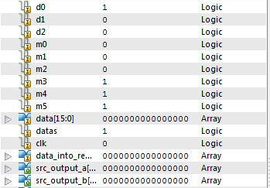

Fs select being updated



After inserting the values into registers 0 and 7. The control word is updated to and registers 0 and 7 and store the result in R1. This is the case in the example below.

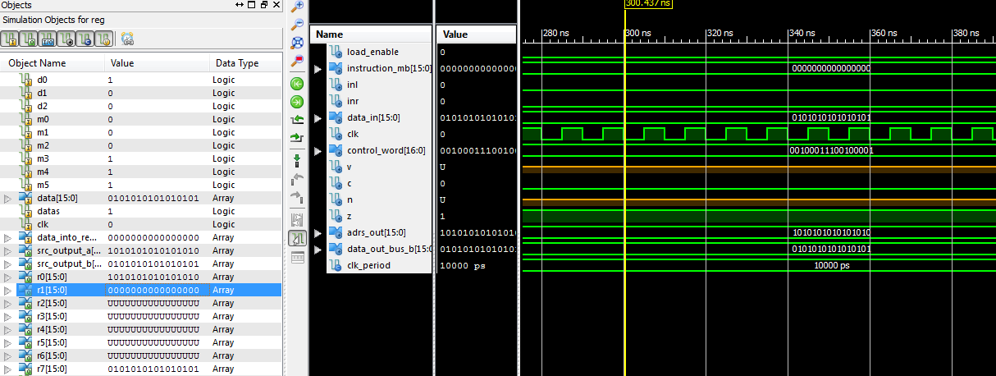

Close up of register results

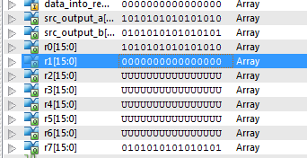

Functional_unit_test.vhd

LIBRARY ieee;

USE ieee.std_logic_1164.ALL;

USE ieee.numeric_std.ALL;

ENTITY Functional_unit_test IS

END Functional_unit_test;

ARCHITECTURE behavior OF Functional_unit_test IS

-- Component Declaration

COMPONENT Functional_Unit

PORT(

fsel : in std_logic_vector(4 downto 0);

a : in std_logic_vector(15 downto 0);

b : in std_logic_vector(15 downto 0);

f : out std_logic_vector(15 downto 0);

IL : in std_logic;

IR : in std_logic;

v : out std_logic;

c : out std_logic;

n : out std_logic;

z : out std_logic );

END COMPONENT;

--output

signal OUTPUT : std_logic_vector(15 downto 0) := (others => '0');

signal v , c , n , z , IL, IR : std_logic := '0';

signal fsel : std_logic_vector(4 downto 0) := (others => '0');

signal a, b, f : std_logic_vector(15 downto 0) := (others => '0');

BEGIN

-- Component Instantiation

uut: Functional_Unit PORT MAP(

fsel => fsel,

a => a,

b => b,

f => f,

IL => IL,

IR => IR,

v => v,

c => c,

n => n,

z => z

);

-- Test Bench Statements

tb : PROCESS

BEGIN

wait for 20 ns; -- wait until global set/reset completes

IL <= '0';

IR <= '0';

a <= "0000111100001111";

b <= "0000101010101010";

wait for 20 ns; -- F = A;

fsel <= "00000";

wait for 20 ns; -- F = A+1;

fsel <= "00001";

wait for 20 ns; -- F = A + B;

fsel <= "00010";

wait for 20 ns; -- F = A+ B +1;

fsel <= "00011";

wait for 20 ns; -- F = A+ NOTB

fsel <= "00100";

wait for 20 ns; -- F = A+ notB +1 -- subtract

fsel <= "00101";

wait for 20 ns; -- F = A -1

fsel <= "00110";

wait for 20 ns; -- F = A

fsel <= "00111";

wait for 20 ns; -- F = A AND B

fsel <= "01000";

wait for 20 ns; -- F = A OR B

fsel <= "01010";

wait for 20 ns; -- F = A XOR B

fsel <= "01100";

wait for 20 ns; -- F = NOT A

fsel <= "01110";

wait for 20 ns; -- F = B

fsel <= "10000";

wait for 20 ns; -- F = sr B

fsel <= "10100";

wait for 20 ns; -- F = sl B

fsel <= "11000";

wait for 20 ns; -- F = sr B

wait; -- will wait forever

END PROCESS tb;

-- End Test Bench

END;

Functional_unit - Waveforms

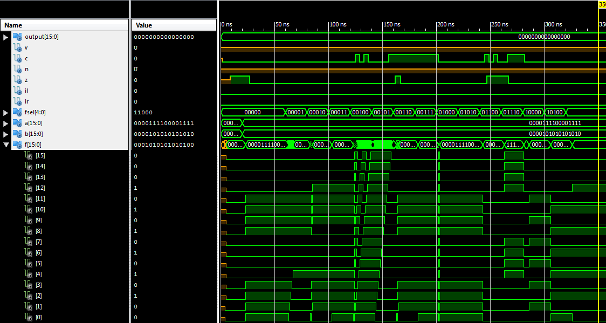

Reg_file_test.vhd

LIBRARY ieee;

USE ieee.std_logic_1164.ALL;

ENTITY Reg_File_Test IS

END Reg_File_Test;

ARCHITECTURE behavior OF Reg_File_Test IS

-- Component Declaration for the Unit Under Test (UUT)

COMPONENT Reg_File

Port (

d0 : in STD_LOGIC;

d1 : in STD_LOGIC;

d2 : in STD_LOGIC;

m0 : in STD_LOGIC;

m1 : in STD_LOGIC;

m2 : in STD_LOGIC;

m3 : in STD_LOGIC;

m4 : in STD_LOGIC;

m5 : in STD_LOGIC;

data : in STD_LOGIC_VECTOR(15 DOWNTO 0);

dataS : in STD_LOGIC;

Clk : in STD_LOGIC;

Data_into_reg : in STD_LOGIC_VECTOR(15 downto 0);

src_output_a : out std_logic_vector(15 downto 0);

src_output_b : out std_logic_vector(15 downto 0);

R0 : out STD_LOGIC_VECTOR(15 DOWNTO 0);

R1 : out STD_LOGIC_VECTOR(15 DOWNTO 0);

R2 : out STD_LOGIC_VECTOR(15 DOWNTO 0);

R3 : out STD_LOGIC_VECTOR(15 DOWNTO 0);

R4 : out STD_LOGIC_VECTOR(15 DOWNTO 0);

R5 : out STD_LOGIC_VECTOR(15 DOWNTO 0);

R6 : out STD_LOGIC_VECTOR(15 DOWNTO 0);

R7 : out STD_LOGIC_VECTOR(15 DOWNTO 0));

END COMPONENT;

--Inputs

signal d0 : std_logic := '0';

signal d1 : std_logic := '0';

signal d2 : std_logic := '0';

signal m0 : std_logic := '0';

signal m1 : std_logic := '0';

signal m2 : std_logic := '0';

signal m3 : std_logic := '0';

signal m4 : std_logic := '0';

signal m5 : std_logic := '0';

signal Data_into_reg : std_logic_vector(15 downto 0) := (others => '0');

signal Clk : std_logic := '0';

signal dataS : std_logic := '0';

signal data : std_logic_vector(15 downto 0) := (others => '0');

--Outputs

signal src_output_a : std_logic_vector (15 downto 0);

signal src_output_b : std_logic_vector (15 downto 0);

signal R0 : std_logic_vector(15 downto 0);

signal R1 : std_logic_vector(15 downto 0);

signal R2 : std_logic_vector(15 downto 0);

signal R3 : std_logic_vector(15 downto 0);

signal R4 : std_logic_vector(15 downto 0);

signal R5 : std_logic_vector(15 downto 0);

signal R6 : std_logic_vector(15 downto 0);

signal R7 : std_logic_vector(15 downto 0);

-- Clock period definitions

constant CLK_period : time := 10 ns;

BEGIN

-- Instantiate the Unit Under Test (UUT)

uut: Reg_File PORT MAP (

d0 => d0,

d1 => d1,

d2 => d2,

m0 => m0,

m1 => m1,

m2 => m2,

m3 => m3,

m4 => m4,

m5 => m5,

Data_into_reg => Data_into_reg,

dataS => dataS,

src_output_a => src_output_a,

src_output_b => src_output_b,

data => data,

CLK => CLK,

R0 => R0,

R1 => R1,

R2 => R2,

R3 => R3,

R4 => R4,

R5 => R5,

R6 => R6,

R7 => R7

);

-- Clock process definitions

CLK_process :process

begin

CLK <= '0';

wait for CLK_period/2;

CLK <= '1';

wait for CLK_period/2;

end process;

-- Stimulus process

stim_proc: process

begin

-- hold reset state for 100 ns.

wait for CLK_period;

-- insert stimulus here

--Allow writing to registers

dataS <= '0';

--Select R0

d0 <= '0';

d1 <= '0';

d2 <='0';

data <= "0000000000000001";

wait for CLK_period*2;

--Select R1

d0 <= '1';

d1 <= '0';

d2 <='0';

data <= "0000000000000010";

wait for CLK_period*2;

--Select R2

d0 <= '0';

d1 <= '1';

d2 <='0';

data <= "0000000000000100";

wait for CLK_period*2;

--Select R3

d0 <= '1';

d1 <= '1';

d2 <='0';

data <= "0000000000001000";

wait for CLK_period*2;

--Select R4

d0 <= '0';

d1 <= '0';

d2 <='1';

data <= "0000000000010000";

wait for CLK_period*2;

--Select R5

d0 <= '1';

d1 <= '0';

d2 <='1';

data <= "0000000000100000";

wait for CLK_period*2;

--Select R6

d0 <= '0';

d1 <= '1';

d2 <='1';

data <= "0000000001000000";

wait for CLK_period*2;

--Select R7

d0 <= '1';

d1 <= '1';

d2 <='1';

data <= "0101010101010101";

wait for CLK_period*2;

--Now load into different registers

dataS <= '1';

--Move R7 to other registers

--Select R7 with mux

m0 <= '1';

m1 <= '1';

m2 <= '1';

wait for CLK_period*2;

--Select R0 with decoder

d0 <= '0';

d1 <= '0';

d2 <= '0';

wait for CLK_period*2;

--Select R1 with decoder

d0 <= '1';

d1 <= '0';

d2 <= '0';

wait for CLK_period*2;

--Select R2 with decoder

d0 <= '0';

d1 <= '1';

d2 <= '0';

wait for CLK_period*2;

--Select R3 with decoder

d0 <= '1';

d1 <= '1';

d2 <= '0';

wait for CLK_period*2;

--Select R4 with decoder

d0 <= '0';

d1 <= '0';

d2 <= '1';

wait for CLK_period*2;

--Select R5 with decoder

d0 <= '1';

d1 <= '0';

d2 <= '1';

wait for CLK_period*2;

--Select R6 with decoder

d0 <= '0';

d1 <= '1';

d2 <= '1';

wait for CLK_period*2;

--Select R7 with decoder

d0 <= '1';

d1 <= '1';

d2 <= '1';

wait for CLK_period*2;

wait;

end process;

END;

Reg_file_test – Waveforms

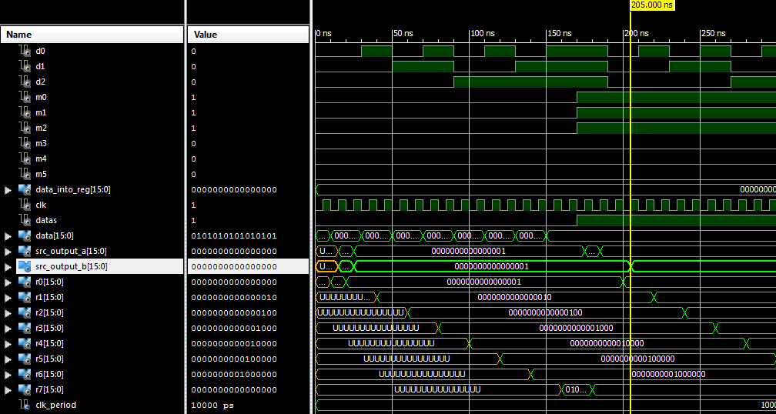

ALU_test.vhd

LIBRARY ieee;

USE ieee.std_logic_1164.ALL;

USE ieee.numeric_std.ALL;

ENTITY ALU_test IS

END ALU_test;

ARCHITECTURE behavior OF ALU_test IS

-- Component Declaration for the Unit Under Test (UUT)

COMPONENT ALU

PORT(

A, B : in std_logic_vector(15 downto 0);

S1 : in std_logic;

S2 : in std_logic;

S3 : in std_logic;

Cin : in std_logic; -- fS0

G : out std_logic_vector(15 downto 0);

c : out std_logic;

v : out std_logic;

n : out std_logic

);

END COMPONENT;

--Inputs

signal S1 : std_logic := '0';

signal S2 : std_logic := '0';

signal S3 : std_logic := '0';

signal Cin : std_logic := '0'; --fS1

signal A : std_logic_vector(15 downto 0) := (others => '0');

signal B : std_logic_vector(15 downto 0) := (others =>'0');

--Outputs

signal G : std_logic_vector(15 downto 0) := (others => '0');

signal cOut : std_logic := '0';

signal v : std_logic := '0';

signal c : std_logic := '0';

signal n : std_logic := '0';

signal z : std_logic := '0';

-- No clocks detected in port list. Replace <clock> below with

-- appropriate port name

BEGIN

-- Instantiate the Unit Under Test (UUT)

uut: ALU PORT MAP (

S1 => S1,

S2 => S2,

S3 => S3,

A => A,

B => B,

G => G,

Cin => Cin,

v => v,

c => c,

n => n

);

-- Stimulus process

stim_proc: process

begin

-- hold reset state for 100 ns.

wait for 20 ns;

A <= "0000000000110000";

B <= "0000000011000000";

-- g == A

Cin <= '0';

S3 <= '0';

S2 <= '0';

S1 <= '0';

wait for 100 ns; -- g == A+1

Cin <= '1';

wait for 100 ns; -- g ==A + B

Cin <= '0';

S3 <= '0';

S2 <= '0';

S1 <= '1';

wait for 100 ns; -- g =A + B +1

Cin <= '1';

wait for 100 ns; -- g = A + B .. not sure

Cin <= '0';

S3 <= '0';

S2 <= '1';

S1 <= '0';

wait for 100 ns; -- g = A + B + 1

Cin <= '1';

wait for 30 ns; -- g = A - 1

Cin <= '0';

S3 <= '0';

S2 <= '1';

S1 <= '1';

wait for 30 ns; -- g = A

Cin <= '1';

wait for 30 ns; -- g = A and B

S3 <= '1';

S2 <= '0';

S1 <= '0';

wait for 30 ns; -- g = A OR B

-- dont need to continously change s2 but Just to make it clear

S3 <= '1';

S2 <= '0';

S1 <= '1';

wait for 30 ns; -- g =A XOR B

S3 <= '1';

S2 <= '1';

S1 <= '0';

wait for 30 ns; -- g = NOT A

S3 <= '1';

S2 <= '1';

S1 <= '1';

wait for 30 ns; --

-- insert stimulus here

wait;

end process;

END;

ALU_test - Waveforms

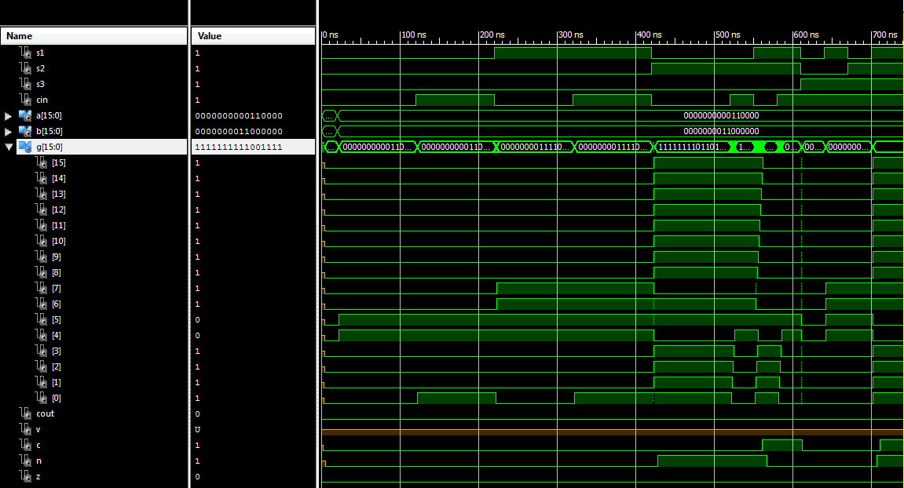

Shifter_test.vhd

-- TestBench Template

LIBRARY ieee;

USE ieee.std_logic_1164.ALL;

USE ieee.numeric_std.ALL;

-- TestBench Template

LIBRARY ieee;

USE ieee.std_logic_1164.ALL;

USE ieee.numeric_std.ALL;

ENTITY Shifter_test IS

END Shifter_test;

ARCHITECTURE behavior OF Shifter_test IS

-- Component Declaration for the Unit Under Test (UUT)

COMPONENT Shifter

PORT(

IL : in std_logic;

IR : in std_logic;

s : in std_logic_vector(1 downto 0);

b : in std_logic_vector (15 downto 0);

O : out std_logic_vector(15 downto 0);

SL0 : out std_logic;

SR0 : out std_logic

);

END COMPONENT;

--Inputs

signal b : std_logic_vector(15 downto 0) := (others => '0');

signal s : std_logic_vector(1 downto 0 ) := (others => '0');

signal IR : std_logic := '0';

signal IL : std_logic := '0';

--outputs

signal O : std_logic_vector(15 downto 0) := (others => '0');

signal SL0 : std_logic := '0';

signal SR0 : std_logic := '0';

--Outputs

signal output : std_logic_vector(15 downto 0);

-- No clocks detected in port list. Replace <clock> below with

-- appropriate port name

BEGIN

-- Instantiate the Unit Under Test (UUT)

uut: Shifter PORT MAP (

IL => IL,

IR => IR,

s => s,

b => b,

O => O,

SL0 => SL0,

SR0 => SR0

);

-- Stimulus process

stim_proc: process

begin

-- hold reset state for 100 ns.

wait for 10 ns;

-- insert stimulus here

b <= "0000101010101010" ;

--Set for In0

s <= "00";

wait for 20 ns;

--Set for In1

s <= "01";

wait for 10 ns;

s <= "10";

wait for 10 ns;

wait;

end process;

END;

Shifter_test - Waveforms

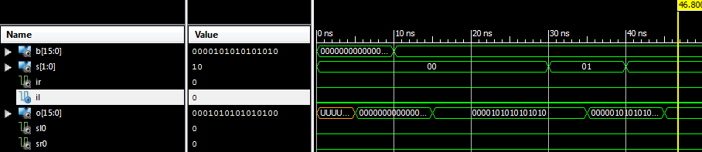

Arithmetic_circuit_test.vhd

-- TestBench Template

LIBRARY ieee;

USE ieee.std_logic_1164.ALL;

USE ieee.numeric_std.ALL;

ENTITY Arithmetic_circuit_test IS

END Arithmetic_circuit_test;

ARCHITECTURE behavior OF Arithmetic_circuit_test IS

-- Component Declaration

COMPONENT Arithmetic_Circuit

PORT(

a : in std_logic_vector(15 downto 0);

b : in std_logic_vector(15 downto 0);

S0 : in std_logic;

S1 : in std_logic;

Cin : in std_logic;

Cout : out std_logic;

g : out std_logic_vector(15 downto 0)

);

END COMPONENT;

-- inputs

SIGNAL S0 : std_logic := '0';

signal S1 : std_logic := '0';

signal Cin : std_logic := '0';

SIGNAL a : std_logic_vector(15 downto 0) := (others => '0');

signal b : std_logic_vector(15 downto 0) := (others => '0');

signal Cout : std_logic := '0';

-- outputs

signal g : std_logic_vector(15 downto 0) := (others => '0');

BEGIN

-- Component Instantiation

uut: Arithmetic_Circuit PORT MAP(

a => a,

b => b,

S0 => S0,

S1 => S1,

Cin => Cin,

Cout => Cout,

g => g

);

-- Test Bench Statements

tb : PROCESS

BEGIN

wait for 20 ns; -- wait until global set/reset completes

A <= "0000000000110000";

B <= "0000000011000000";

wait for 20 ns;

S1 <= '0';

S0 <= '0';

Cin <= '0';

wait for 20 ns;

Cin <= '1';

wait for 20 ns;

S1 <= '0';

S0 <= '1';

Cin <= '0';

wait for 20 ns;

Cin <= '1';

wait for 20 ns;

S1 <= '1';

S0 <= '0';

Cin <= '0';

wait for 20 ns;

Cin <= '1';

wait for 20 ns;

S1 <= '1';

S0 <= '1';

Cin <= '0';

wait for 20 ns;

Cin <= '1';

wait for 20 ns;

-- Add user defined stimulus here

wait; -- will wait forever

END PROCESS tb;

-- End Test Bench

END;

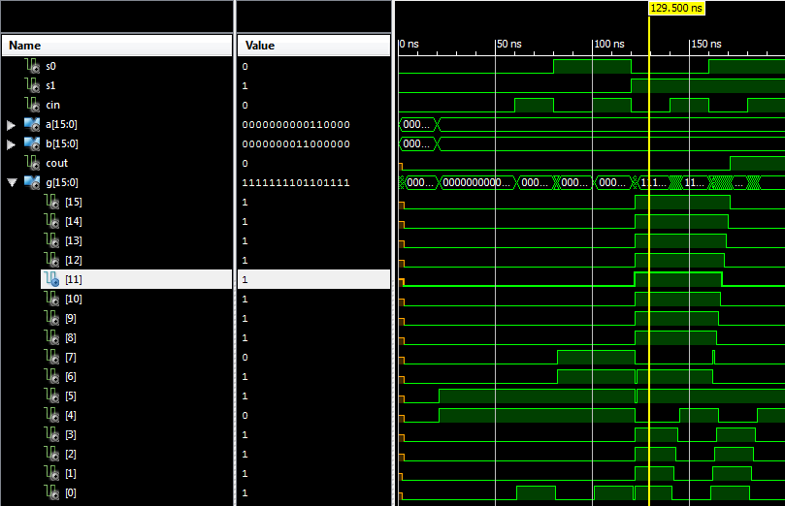

Logic_circuit_test.vhd

LIBRARY ieee;

USE ieee.std_logic_1164.ALL;

ENTITY logic_circuit_test IS

END logic_circuit_test;

ARCHITECTURE behavior OF logic_circuit_test IS

-- Component Declaration for the Unit Under Test (UUT)

COMPONENT logic_Circuit

PORT(

a : IN std_logic_vector(15 downto 0);

b : IN std_logic_vector(15 downto 0);

S0 : IN std_logic;

S1 : IN std_logic;

g : OUT std_logic_vector(15 downto 0)

);

END COMPONENT;

--Inputs

signal a : std_logic_vector(15 downto 0) := (others => '0');

signal b : std_logic_vector(15 downto 0) := (others => '0');

signal S0 : std_logic := '0';

signal S1 : std_logic := '0';

--Outputs

signal g : std_logic_vector(15 downto 0);

-- No clocks detected in port list. Replace <clock> below with

-- appropriate port name

BEGIN

-- Instantiate the Unit Under Test (UUT)

uut: logic_Circuit PORT MAP (

a => a,

b => b,

S0 => S0,

S1 => S1,

g => g

);

-- Stimulus process

stim_proc: process

begin

-- hold reset state for 100 ns.

wait for 20 ns;

a <= "0000000000000001";

b <= "0000000000001111";

wait for 10 ns;

S0 <= '0';

S1 <= '0';

wait for 10 ns;

S0 <= '1';

S1 <= '0';

wait for 10 ns;

S0 <= '0';

S1 <= '1';

wait for 10 ns;

S0 <= '1';

S1 <= '1';

-- insert stimulus here

wait;

end process;

END;

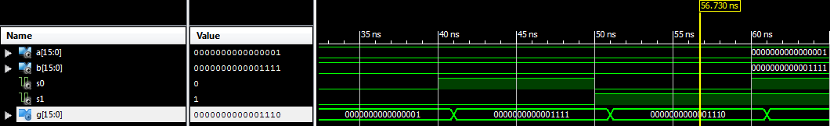

RippleAdder_test.vhd

-- TestBench Template

LIBRARY ieee;

USE ieee.std_logic_1164.ALL;

USE ieee.numeric_std.ALL;

ENTITY RippleAdder_test IS

END RippleAdder_test;

ARCHITECTURE behavior OF RippleAdder_test IS

-- Component Declaration for the Unit Under Test (UUT)

COMPONENT RippleAdder

PORT(

B, A : in std_logic_vector(15 downto 0);

C0 : in std_logic; -- input

S : out std_logic_vector(15 downto 0);

C15 : out std_logic -- output

);

END COMPONENT;

--Inputs

signal B : std_logic_vector(15 downto 0) := (others => '0');

signal A : std_logic_vector(15 downto 0) := (others => '0');

signal C0 : std_logic := '0';

--Outputs

signal s : std_logic_vector(15 downto 0);

signal C15 : std_logic := '0';

-- No clocks detected in port list. Replace <clock> below with

-- appropriate port name

BEGIN

-- Instantiate the Unit Under Test (UUT)

uut: RippleAdder PORT MAP (

A => A,

B => B,

S => S,

C0 => C0,

C15 => C15

);

-- Stimulus process

stim_proc: process

begin

-- hold reset state for 100 ns.

wait for 20 ns;

-- insert stimulus here

A <= "0000000100010001";

B <= "0000000100010001";

--Set for a

C0 <= '0';

wait for 20 ns;

--Set for b

wait for 20 ns;

B <= x"FFFF";

wait for 20 ns;

A <= x"0001";

wait for 20 ns;

A<= x"8000";

B<= x"8000";

wait for 20 ns;

wait;

end process;

END;

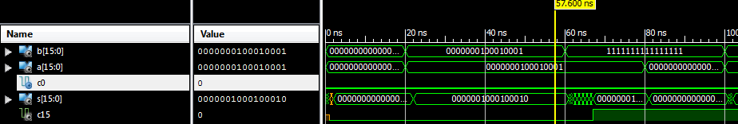

BInput_logic_test.vhd

LIBRARY ieee;

USE ieee.std_logic_1164.ALL;

ENTITY B_input_logic_test IS

END B_input_logic_test;

ARCHITECTURE behavior OF B_input_logic_test IS

-- Component Declaration for the Unit Under Test (UUT)

COMPONENT B_Input_Logic

PORT(

b : IN std_logic_vector(15 downto 0);

S0 : IN std_logic;

S1 : IN std_logic;

y : OUT std_logic_vector(15 downto 0)

);

END COMPONENT;

--Inputs

signal b : std_logic_vector(15 downto 0) := (others => '0');

signal S0 : std_logic := '0';

signal S1 : std_logic := '0';

--Outputs

signal y : std_logic_vector(15 downto 0) := (others => '0');

-- No clocks detected in port list. Replace <clock> below with

-- appropriate port name

BEGIN

-- Instantiate the Unit Under Test (UUT)

uut: B_Input_Logic PORT MAP (

b => b,

S0 => S0,

S1 => S1,

y => y

);

-- Stimulus process

stim_proc: process

begin

-- hold reset state for 100 ns.

wait for 20 ns;

b <= "0000000000000000";

wait for 5 ns;

S0 <= '0';

S1 <= '0';

wait for 10 ns;

S0 <= '0';

S1 <= '1';

wait for 10 ns;

S0 <= '1';

S1 <= '0';

wait for 10 ns;

S0 <= '1';

S1 <= '1';

wait for 10 ns;

-- insert stimulus here

wait;

end process;

END;

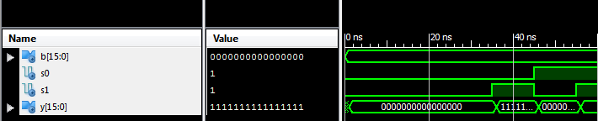

Detect_zero_test.vhd

LIBRARY ieee;

USE ieee.std_logic_1164.ALL;

ENTITY zeroDetect_test IS

END zeroDetect_test;

ARCHITECTURE behavior OF zeroDetect_test IS

-- Component Declaration for the Unit Under Test (UUT)

COMPONENT zeroDetect

PORT(

input : IN std_logic_vector(15 downto 0);

outputFlag : OUT std_logic;

output : out std_logic_vector(15 downto 0)

);

END COMPONENT;

--Inputs

signal input : std_logic_vector(15 downto 0) := (others => '0');

--Outputs

signal output : std_logic_vector(15 downto 0) := (others => '0');

signal outputFlag : std_logic;

-- No clocks detected in port list. Replace <clock> below with

-- appropriate port name

BEGIN

-- Instantiate the Unit Under Test (UUT)

uut: zeroDetect PORT MAP (

input => input,

outputFlag => outputFlag,

output => output

);

-- Stimulus process

stim_proc: process

begin

-- hold reset state for 100 ns.

wait for 20 ns;

input <= "1111111111111111";

wait for 10 ns;

input <= "0000000000000000";

wait for 10 ns;

-- insert stimulus here

wait;

end process;

END;

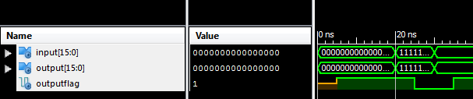

Mux_2_1_test.vhd

LIBRARY ieee;

USE ieee.std_logic_1164.ALL;

ENTITY Mux2_1_test IS

END Mux2_1_test;

ARCHITECTURE behavior OF Mux2_1_test IS

-- Component Declaration for the Unit Under Test (UUT)

COMPONENT Mux_2_1

PORT(

sel : IN std_logic;

a : IN std_logic_vector(15 downto 0);

b : IN std_logic_vector(15 downto 0);

g : OUT std_logic_vector(15 downto 0)

);

END COMPONENT;

--Inputs

signal sel : std_logic := '0';

signal a : std_logic_vector(15 downto 0) := (others => '0');

signal b : std_logic_vector(15 downto 0) := (others => '0');

--Outputs

signal g : std_logic_vector(15 downto 0);

-- No clocks detected in port list. Replace <clock> below with

BEGIN

-- Instantiate the Unit Under Test (UUT)

uut: Mux_2_1 PORT MAP (

sel => sel,

a => a,

b => b,

g => g

);

-- Stimulus process

stim_proc: process

begin

-- hold reset state for 100 ns.

wait for 20 ns;

a <= "0000000000000000";

b <= "0000000000000001";

wait for 10 ns;

sel <= '0';

wait for 10 ns;

sel <= '1';

-- insert stimulus here

wait;

end process;

END;

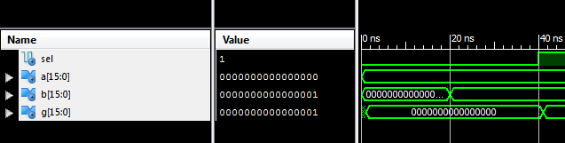

Shifter_mux_test.vhd

LIBRARY ieee;

USE ieee.std_logic_1164.ALL;

ENTITY ShifterMux_test IS

END ShifterMux_test;

ARCHITECTURE behavior OF ShifterMux_test IS

-- Component Declaration for the Unit Under Test (UUT)

COMPONENT shifter_mux

PORT(

A : IN std_logic;

B : IN std_logic;

C : IN std_logic;

S : IN std_logic_vector(1 downto 0);

H : OUT std_logic

);

END COMPONENT;

--Inputs

signal A : std_logic := '0';

signal B : std_logic := '0';

signal C : std_logic := '0';

signal S : std_logic_vector(1 downto 0) := (others => '0');

--Outputs

signal H : std_logic;

-- No clocks detected in port list. Replace <clock> below with

-- appropriate port name

BEGIN

-- Instantiate the Unit Under Test (UUT)

uut: shifter_mux PORT MAP (

A => A,

B => B,

C => C,

S => S,

H => H

);

-- Stimulus process

stim_proc: process

begin

-- hold reset state for 100 ns.

wait for 20 ns;

S <= "00";

wait for 10 ns;

A <= '1';

wait for 10 ns;

S<= "01";

A <= '0';

wait for 10 ns;

B <= '1';

wait for 10 ns;

S<= "10";

wait for 10 ns;

C <= '1';

B <= '0';

wait for 20 ns;

-- insert stimulus here

wait;

end process;

END;

